Date: October 16, 2017 Etapa1.bdf Project: Etapa1

[4]WS | SW[3] | SW[2] | SW[1]
INPUT | INPUT | INPUTVCC | INPUT
VCC | VCC |  | VCC
PIN_W12PIN_V12PIN_M22PIN_L21
 |  |  | NOT
 |  |  | inst20
 |  |  | NOT | AND4
 |  |  | inst21
 |  |  | NOT
 |  |  | inst22
 |  |  | NOT | inst18 | OR2
 |  |  | NOT | inst18 | OUTPUT | HEX0[0]
 |  |  | inst23 | AND4 | inst26 | PIN_J2
 |  |  | NOT |  | inst26 | PIN_J2
 |  |  | inst24
 |  |  | NOT
 |  |  | inst25 | inst19
 |  |  | NOT | AND4
 |  |  | inst
 |  |  | NOT |  |  | PIN_J1
 |  |  | inst27 | inst34 | OR2
 |  |  |  |  | OUTPUT | HEX0[1]
 |  |  | NOT | AND4 | inst33
 |  |  | inst29
 |  |  | NOT
 |  |  | inst28 | inst35
 |  |  | NOT |  |  | PIN_H2
 |  |  | inst41
 |  |  | NOT | AND4
 |  |  | inst43 |  | OUTPUT | HEX0[2]
 |  |  | NOT
 |  |  | inst42 | inst40
 |  |  | NOT | AND4
 |  |  | inst47
 |  |  | NOT
 |  |  | inst49 |  |  | PIN_H1
 |  |  | NOT |  |  | PIN_H1
 |  |  | NOT | inst44
 |  |  | inst48
 |  |  | NOT | AND4
 |  |  | inst50 |  | OR3
 |  |  | NOT |  | OUTPUT | HEX0[3]
 |  |  | inst51 |  | inst54
 |  |  | NOT | inst45
 |  |  | inst52
 |  |  | NOT | AND4
 |  |  | inst53
 |  |  |  |  |  | PIN_F2
 |  |  |  | inst46
 |  |  | NOT | AND2
 |  |  | inst55
 |  |  |  | inst60
 |  |  | NOT | AND3 | OR3
 |  |  | inst56 |  | OUTPUT | HEX0[4]
 |  |  | NOT
 |  |  | inst57 | inst61 | inst63
 |  |  |  |  |  | PIN_F1
 |  |  | NOT | AND3
 |  |  | inst58
 |  |  | NOT
 |  |  | inst59 | inst62
 |  |  | NOT | AND3
 |  |  | inst64 |  |  | PIN_E2
 |  |  | NOT |  |  | PIN_E2
 |  |  | inst65 | inst66
 |  |  | NOT | AND3 | OR3
 |  |  | inst67 |  | OUTPUT | HEX0[5]
 |  |  | NOT
 |  |  | inst68 | inst69 | inst71
 |  |  | NOT | AND3
 |  |  | inst70
 |  |  |  | inst72
 |  |  | NOT | AND3
 |  |  | NOT
 |  |  | NOT
 |  |  | inst79
 |  |  | inst80 | inst78 | OR2
 |  |  | inst81 | inst78
 |  |  | NOT | AND4 | OUTPUT | HEX0[6]
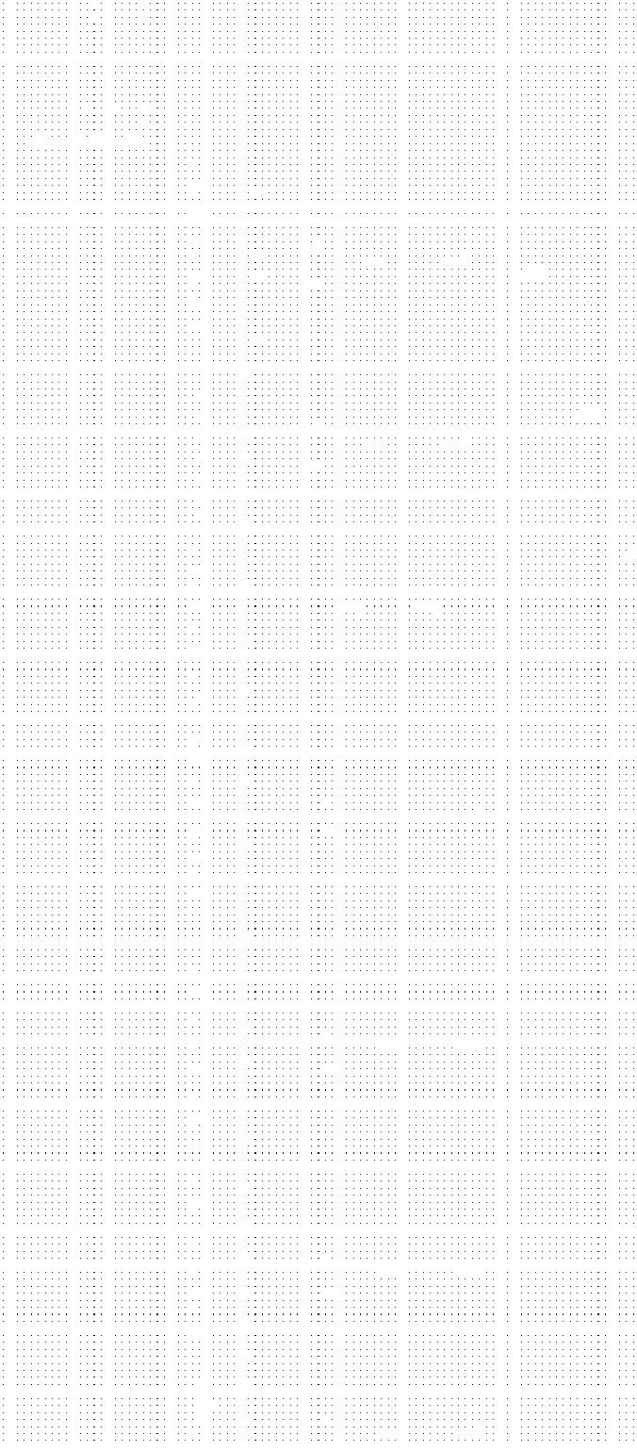
inst77
inst75

inst76


Page 1 of 1 Revision: Etapa1

